

Primary health care center

Register a new patient

Register

Search

Search

Aadhar Number:

Contact Number:

Date: dd/mm/yyyy

Password:

LOGIN

Username:

Forgot password ?

Register User

Number of patients visited

Male: Female: Children: Total:

View Yearly Analysis

View Monthly Analysis

View Weekly Analysis

Search patient

Photo

Aadhar Number:

**Patient Details**

First Name:

Middle Name:

Last name:

Date Of Birth:

Address:

Pin code:

Contact Number:

Economic Status:

Disability:

Allergies:

**+**

**+**

Scheme:

**Insurance Details**

Insurance Number:

Company Name:

Address:

Contact Number:

Category:

**Emergency Contact**

Name:

Address:

Contact Number:

**+**

Relationship:

Submit

Photo



**Patient Details**

Name: xxx

View personal information

Update information

Test reports

Operation details

Medication History

Disease:

Other Complications:

**Prescription**

Medicine name:

**+**

Quantity:

**Test**

Report name:

Browse

**+**

Upload file

**Operation**

Name:

Date:

Description:

**+**

Browse

Upload report:

Submit

Add new report

|  |  |  |  |  |
| --- | --- | --- | --- | --- |
| **Visit Date** | **Medicine Name** | **Quantity** | **Disease diagnosed** | **Other Complications** |
|  |  |  |  |  |
|  |  |  |  |  |
|  |  |  |  |  |
|  |  |  |  |  |
|  |  |  |  |  |
|  |  |  |  |  |
|  |  |  |  |  |

Back

|  |  |
| --- | --- |
| **Test Report Name** | **File Uploaded** |
|  |  |
|  |  |
|  |  |
|  |  |
|  |  |

**Test Reports**

Back

**Medication History**

**Upload Test Report**

Test Report name:

Browse

Upload file

Submit

**Upload Operation Details**

Name:

Date:

Description:

Browse

Upload report:

Submit

Add new operation details

**Update Information**

Update

Update

Pin code:

Address:

:

Contact Number:

**Operation Details**

Back

|  |  |  |  |
| --- | --- | --- | --- |
| **Operation Name** | **Date** | **Description** | **Files uploaded** |
|  |  |  |  |
|  |  |  |  |
|  |  |  |  |
|  |  |  |  |

Back

|  |  |
| --- | --- |
| **Personal Details** | |
| Aadhar Number |  |
| First Name |  |
| Middle Name |  |
| Last Name |  |
| Date of Birth |  |
| Age |  |
| Address |  |
| Pin code |  |
| Contact Number |  |
| Economic details |  |
| Disability |  |
| Allergy |  |
| Schemes |  |
| **Insurance Details** | |
| Insurance Number |  |
| Company Name |  |
| Address |  |
| Contact Number |  |
| Category |  |
| **Emergency Contact** | |
| Name |  |
| Address |  |
| Contact Number |  |
| Relationship |  |

**Personal Information**

**Weekly Analysis**

Submit

Date:

dd/mm/yyyy

|  |  |  |  |  |  |  |  |  |  |
| --- | --- | --- | --- | --- | --- | --- | --- | --- | --- |
| **S. No** | **IDSP Disease** | **Number of cases seen in the week** | | | | | | | **Total** |
|  |  | **Mon** | **Tue** | **Wed** | **Thu** | **Fri** | **Sat** | **Sun** |  |
| 1 | Acute diarrheal disease (including acute gastroenteritis) |  |  |  |  |  |  |  |  |
| 2 | Bacillary dysentery |  |  |  |  |  |  |  |  |
| 3 | Viral hepatitis |  |  |  |  |  |  |  |  |
| 4 | Enteric fever |  |  |  |  |  |  |  |  |
| 5 | Malaria |  |  |  |  |  |  |  |  |
| 6 | Dengue/ DHF/ DSS |  |  |  |  |  |  |  |  |
| 7 | Chikungunya |  |  |  |  |  |  |  |  |
| 8 | Acute encephalitis syndrome (AES) |  |  |  |  |  |  |  |  |
| 9 | Meningitis |  |  |  |  |  |  |  |  |
| 10 | Measles |  |  |  |  |  |  |  |  |
| 11 | Diphtheria |  |  |  |  |  |  |  |  |
| 12 | Pertussis |  |  |  |  |  |  |  |  |
| 13 | Chicken pox |  |  |  |  |  |  |  |  |
| 14 | Fever of unknown origin (PUO) |  |  |  |  |  |  |  |  |
| 15 | Acute respiratory infection (ARI)/ influenza like illness (ILI) |  |  |  |  |  |  |  |  |
| 16 | Pneumonia |  |  |  |  |  |  |  |  |
| 17 | Leptospirosis |  |  |  |  |  |  |  |  |
| 18 | Acute flaccid paralysis <15 years of age |  |  |  |  |  |  |  |  |
| 19 | Dog bite |  |  |  |  |  |  |  |  |
| 20 | Snake bite |  |  |  |  |  |  |  |  |
| 21 | Any other |  |  |  |  |  |  |  |  |

Generate PDF

Print

**Monthly Analysis**

Generate PDF

Print

|  |  |  |
| --- | --- | --- |
| **S. No** | **IDSP Disease** | **Total Number of cases** |
| 1 | Acute diarrheal disease (including acute gastroenteritis) |  |
| 2 | Bacillary dysentery |  |
| 3 | Viral hepatitis |  |
| 4 | Enteric fever |  |
| 5 | Malaria |  |
| 6 | Dengue/ DHF/ DSS |  |
| 7 | Chikungunya |  |
| 8 | Acute encephalitis syndrome (AES) |  |
| 9 | Meningitis |  |
| 10 | Measles |  |
| 11 | Diphtheria |  |
| 12 | Pertussis |  |
| 13 | Chicken pox |  |
| 14 | Fever of unknown origin (PUO) |  |
| 15 | Acute respiratory infection (ARI)/ influenza like illness (ILI) |  |
| 16 | Pneumonia |  |
| 17 | Leptospirosis |  |
| 18 | Acute flaccid paralysis <15 years of age |  |
| 19 | Dog bite |  |
| 20 | Snake bite |  |
| 21 | Any other |  |

Submit

mm

Enter month:

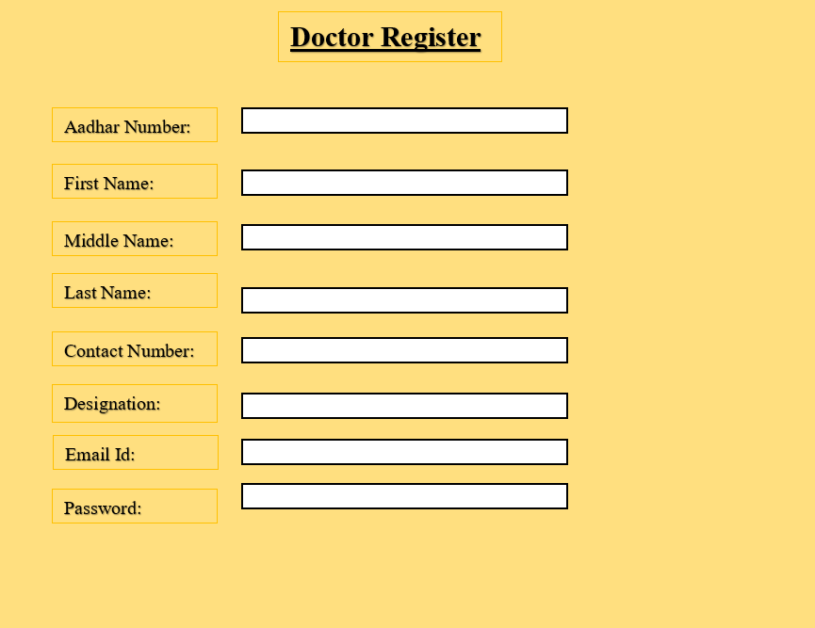

Submit

Reset password

Enter your email address:

Generate PDF

Print

|  |  |  |  |  |  |  |  |  |  |  |  |  |  |  |
| --- | --- | --- | --- | --- | --- | --- | --- | --- | --- | --- | --- | --- | --- | --- |
| **S. No** | **IDSP Disease** | **Number of cases seen in the week** | | | | | | | | | | | | **Total** |
|  |  | **Jan** | **Feb** | **Mar** | **Apr** | **May** | **Jun** | **Jul** | **Aug** | **Sep** | **Oct** | **Nov** | **Dec** |  |
| 1 | Acute diarrheal disease (including acute gastroenteritis) |  |  |  |  |  |  |  |  |  |  |  |  |  |
| 2 | Bacillary dysentery |  |  |  |  |  |  |  |  |  |  |  |  |  |
| 3 | Viral hepatitis |  |  |  |  |  |  |  |  |  |  |  |  |  |
| 4 | Enteric fever |  |  |  |  |  |  |  |  |  |  |  |  |  |
| 5 | Malaria |  |  |  |  |  |  |  |  |  |  |  |  |  |
| 6 | Dengue/ DHF/ DSS |  |  |  |  |  |  |  |  |  |  |  |  |  |
| 7 | Chikungunya |  |  |  |  |  |  |  |  |  |  |  |  |  |
| 8 | Acute encephalitis syndrome (AES) |  |  |  |  |  |  |  |  |  |  |  |  |  |
| 9 | Meningitis |  |  |  |  |  |  |  |  |  |  |  |  |  |
| 10 | Measles |  |  |  |  |  |  |  |  |  |  |  |  |  |
| 11 | Diphtheria |  |  |  |  |  |  |  |  |  |  |  |  |  |
| 12 | Pertussis |  |  |  |  |  |  |  |  |  |  |  |  |  |
| 13 | Chicken pox |  |  |  |  |  |  |  |  |  |  |  |  |  |
| 14 | Fever of unknown origin (PUO) |  |  |  |  |  |  |  |  |  |  |  |  |  |
| 15 | Acute respiratory infection (ARI)/ influenza like illness (ILI) |  |  |  |  |  |  |  |  |  |  |  |  |  |
| 16 | Pneumonia |  |  |  |  |  |  |  |  |  |  |  |  |  |
| 17 | Leptospirosis |  |  |  |  |  |  |  |  |  |  |  |  |  |
| 18 | Acute flaccid paralysis <15 years of age |  |  |  |  |  |  |  |  |  |  |  |  |  |
| 19 | Dog bite |  |  |  |  |  |  |  |  |  |  |  |  |  |
| 20 | Snake bite |  |  |  |  |  |  |  |  |  |  |  |  |  |
| 21 | Any other |  |  |  |  |  |  |  |  |  |  |  |  |  |

**Yearly analysis**

Submit

yyyy

Enter the year: